# The Rebound Effect

Economists use the idea of elasticity in a similar way, to describe responsiveness to a change in market conditions. In the previous chapter, we learned that demand and supply regulate economic activity by responding to the interests of buyers and sellers through prices. A higher price causes the quantity demanded to fall. A lower price causes the quantity demanded to rise. How strongly the quantity consumed or produced responds to a change in price is its elasticity.

High and Low Elasticity

A high elasticity means a large, very responsive change in quantity, while low elasticity means a small change; so the change in price is like the drop height of a ball, and the change in quantity is like the rebound height.

This is an important concept in economics. Understanding elasticity helps us determine the impact of government policy on the economy, to vote more intelligently, and even to make wisher day-to-day decisions.

BIG QUESTIONS

* What is the price elasticity of demand, and what are its determinants?
  + The price elasticity of demand is a measure of the responsiveness of quantity demanded to a change in price.
  + Demand will generally be more elastic if there are many substitutes available, if the item accounts for a larger share of the consumer’s budget, if them is a luxury good, if the market is more narrowly defined, or if the consumer has plenty of time to make a decision.
  + Economists categorize time in three distinct periods: (1) the immediate run, when there is no time for consumers to adjust their behavior; (2) the short run, when consumers can adjust, but only partially; and (3) the long run, when consumers have time to fully adjust to market conditions.
  + The price elasticity of demand is calculated by dividing the percentage change in the quantity demanded by the percentage change in price. A value of zero indicates that the quantity demanded does not respond to a price change; if the price elasticity is zero, demand is said to be perfectly inelastic. When the price elasticity is zero, demanded is between 0 and -1, demand is inelastic. If the price elasticity of demand is less than -1, demand is elastic. When price elasticity is exactly -1, the item has unitary elasticity.
* How do changes in income and the prices of other goods affect elasticity?
  + The income elasticity of demand measures how a change in income affects spending. Normal goods have a positive income elasticity; inferior goods have a negative income elasticity.
  + The cross-price elasticity of demand measures the responsiveness of the quantity demanded of one good to a change in the price of a related good. Positive values for the cross-price elasticity mean that the goods are substitutes, while negative values indicate that the two goods are complements. If the cross-price elasticity is zero, then the two goods are not related to each other.
* What is the price elasticity of supply?
  + The price elasticity of supply is a measure of the responsiveness of the quantity supplied to a change in price. Supply will generally be more elastic if producers have flexibility in the production process and ample time to adjust production.
  + The price elasticity of supply is calculated by dividing the percentage change in the quantity supplied by the percentage change in price. A value of zero indicates that the quantity supplied does not respond to a price change; if the price elasticity of supply is zero, supply is said to be perfectly inelastic. When the price elasticity of supply is between 0 and 1, demand is relatively inelastic. If the price elasticity of supply is greater than 1, supply is elastic.
* How do the price elasticities of demand and supply relate to each other?
  + The interplay between the price elasticity of demand and the price elasticity of supply determines the magnitude of the resulting price change.

What is the Price Elasticity of Demand, what are its Determinants?

With goods like pasta, where consumers can easily purchase a substitute, we think of demand as being responsive. That is, a small change in price will likely cause many people to switch from one good to another. In contrast, many things in life are irreplaceable or have few good substitutes…consumers are unresponsive, or unwilling to change their behavior, even when the price of the good or service changes.

Elasticity is a measure of the responsiveness of buyers and sellers to changes in price or income. Elasticity is a useful concept because it allows us to measure how much consumers and producers change their behavior when either price or income changes. In the next section, we look at the factors that determine the price elasticity of demand.

# Determinants of the Price of Elasticity of Demand

The law of demand tells us that as price goes up, the quantity demanded goes down; and as price goes down, the quantity demanded goes up. In other words, there is a negative relationship between the price of a good and the quantity demanded. Elasticity allows us to measure how much the quantity demanded changes in response to a change in price. If the quantity demanded changes significantly as a result of a price change, then demand is elastic. If the quantity demanded changes a small amount as a result of a price change, then demand is inelastic.

The price elasticity of demand measures the responsiveness of quantity demanded to a change in price. Five determinants play a crucial role in influencing whether demand will be elastic or inelastic: the existence of substitutes, the share of the budget spent on a good, whether the good is a necessity or a luxury good, how broadly defined the market is and time.

# The existence of substitutes (more substitutes = more elastic (responsive))

The most important determinant of price elasticity is the number of substitutes available. When substitutes are plentiful, market forces tilt in favor of the consumer. When there is no good substitutes? There is no amusement park quite like Disney; nowhere! Because the experience is unique, the number of close substitutes is small, therefore, demand is more inelastic, or less responsive to price changes. To some degree, the price elasticity of demand depends on consumer preferences; ultimately, whether demand is inelastic, or elastic depends on the buyer’s preferences and resources.

## The share of the budget (bigger share = more elastic (reponsive)) spent on the good

Demand is much more inelastic for inexpensive items on sale. For example, if a candy bar is discounted 10%, the price falls by pennies. The savings from switching candy bars is not enough to make a difference in what you can afford elsewhere. Therefore, the incentive to switch is small; most consumers still buy their favorite candy because the savings gained from purchasing a less desirable candy bar are small in comparison to the consumer’s budget.

## Necessities vs. Luxury Goods (= more elastic (responsive))

When consumers purchase a necessity, they are generally thinking about the need, not the price. When the need trumps the price, we expect demand to be relatively inelastic. Therefore, the demand for things like cars, textbooks, and heating oil all tend to have inelastic demand; but some goods are necessities, such as having to pay your rent and water bill, purchase gasoline (or diesel) for your car, and eat.

## Whether the market is broadly or narrowly defined

The more broadly we define a market for a good, the harder it is to live without.

## Time (more time = more elastic (repsonsive)) and Adjustment Process

When the market price changes, consumers and sellers respond, but that response does not remain the same over time. As time passes, both consumers and producers are able to find substitutes. To understand these different market responses, when considering elasticity economists consider time in three distinct periods: the *immediate run*, the *short run*, and *the long run*.

***In the immediate run***, there is no time for consumers to adjust behavior; consider the demand for gasoline. When the gas tank is empty, you have to stop at the nearest gas station and pay the posted price. Filling up as soon as possible is more important than driving around and searching for the lowest price. Inelastic demand exists whenever price is secondary to the desire to attain a certain amount of the good; so in the case of an empty tank, the demand for gasoline is inelastic.

***There is no time to adjust***

But what if your tank is not empty? The ***short run*** is a period of time when consumers can partially adjust their behavior (in this case, we can search for a good deal on gas). In the short run, we can make decisions that reflect our immediate or short-term wants, needs, or limitations. When consumers have some time to make a purchase, they gain flexibility; they can shop for lower prices at the pump, carpool to save gas, or even change how often they drive. In the short run, flexibility reduces the demand for expensive gasoline and makes consumer demand more elastic.

***There is time to partially adjust***

Finally, if we relax the time constraint completely, it is possible to use even less gasoline. The ***long run*** is a period of time consumers have time to fully adjust to market conditions. ***In the long run, we make decisions that reflect our wants, needs, and limitations over a long time horizon.*** If gasoline prices are high in the long run, consumers can relocate closer to work and purchase fuel-efficient cars. These changes further reduce the demand for gasoline. As a result of the flexibility that additional time gives the consumer, the demand for gasoline becomes more elastic.

**There is time to fully adjust**

We have looked at the five determinants of elasticity - substitutes, the share of the budget spent on the good, necessities versus luxury goods, whether the market is broadly or narrowly defined, and time. Each is significant, but the number of substitutes tends to be the most influential factor and dominates the others.

# Computing the Price Elasticity of Demand

Until that point, our discussion of elasticity has been descriptive. However, to apply the concept of elasticity in decision making, we need to view it more quantitatively. If a government is considering a new tax, it needs to know how much revenue that tax will generate. These are questions about elasticity that we can evaluate by using a mathematical formula.

## The price elasticity of demand formula

$price elasticity of demand= E_{D}=\frac{percentage change in the quantity}{percentage change in price}$

## The midpoint method

Economists use the ***midpoint method***, which gives the same answer for elasticity no matter what point you begin with. The midpoint method merely specifies how to plugin the initial and ending values for price and quantity to determine the percentage changes. Q1 and P1 are the initial values, and Q2 and P2 are the ending values.

$$E_{D}=\frac{change in Q ÷ average value of Q}{change in P ÷ average value of P}$$

$=\frac{(Q_{2}-{ Q}_{1})÷[(Q_{1}+Q_{2})÷2]}{(P_{2}-P_{1})÷[(P_{1}+P_{2})÷]}$ 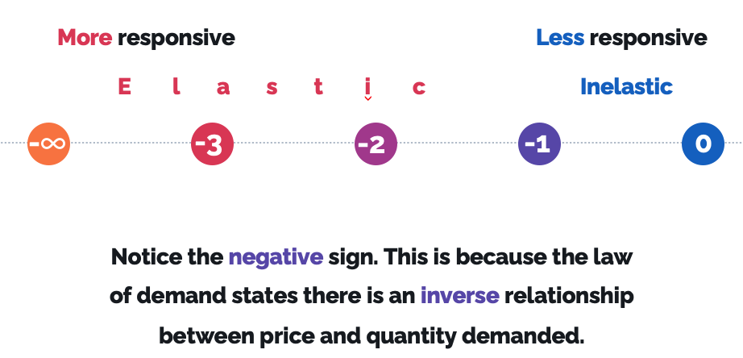

**The midpoint method is the preferred method for solving elasticity problems.**

When the elasticity coefficient is less than -1, the opposite is true, and demand is elastic.

# Graphing the Price Elasticity of DemandVisualizing the Midpoint Method

Visualizing elasticity graphically helps us understand the relationship between elastic and inelastic demand. As demand becomes increasingly elastic, or responsive to price changes, the demand curve flattens. The range of elasticity runs from perfectly inelastic through perfectly elastic.

## Perfectly inelastic demand

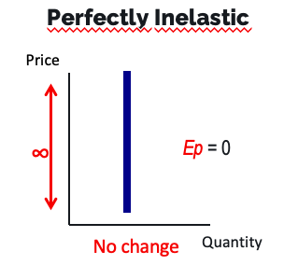

When zero is in the numerator in the formula of price elasticity of demand, we know that the answer will be zero no matter what we find in the denominator. This means that the demand is perfectly inelastic.

## Relatively Inelastic demand

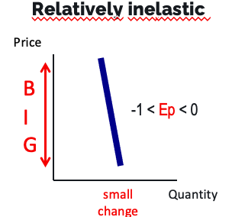

When the change on the quantity axis is small compared with the change on the price axis, the price elasticity is ***relatively inelastic.*** Plugging in these changes into the elasticity formula, we get $\frac{percentage change in Q_{D}}{percentage change in P}=\frac{small change}{large change}$. Recall that the law of demand describes a negative relationship between price and quantity axes always be in opposite directions; a price elasticity of zero tells us that there’s no change in the quantity demanded when price changes. So when demand is relatively inelastic, the price elasticity of demand must be closer to zero; therefore, the price elasticity of demand is between 0 and -1 when demand is relatively inelastic.

## Relatively elastic demand

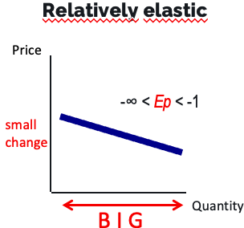

Because there are many good substitutes for “x” item, the demand for “x” item is relatively elastic. The flexibility of consumer demands for “x” item is illustrated by the degree of responsiveness we see along the quantity axis relative to the change exhibited along the price axis. We can observe this responsiveness by noting that a relatively elastic demand curve is flatter than an inelastic demand curve; so whereas perfectly inelastic demand shows no change in demand with an increase in price; and relatively inelastic demand shows a small change in quantity demanded with an increase in price; relatively elastic demand shows a large change in quantity demanded with an increase in price.

Placing this information into the elasticity formula gives us: $E_{x}=\frac{percentage change in Q_{D}}{percentage change in P}=\frac{large change}{small change}$. Now the numerator – the percentage change in $Q_{D}$– is large, and the denominator – the percentage change in P – is small; that means $E_{D}$ is less than -1. Recall that the sign must be negative, because there is a negative relationship between price and the quantity demanded; as the price elasticity of demand move farther away from zero, the consumer becomes more responsive to a price change, thus a small change in price of an item will have a large effect on the quantity demanded because of many good substitutes for the item.

## Perfectly elastic demand

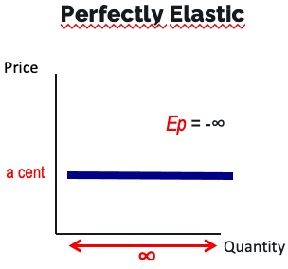

Interesting example: the demand for a $10 bill; Would you pay $11 to get a $10 bill? No. Would you pay $10.01 for a $10? Still no; however, when the price drops to $10, you will probably become indifferent (that is, you will be equally satisfied with paying $10.00 for the $10 bill or not making the trade). The real magic here occurs when the price drops to $9.99, how many $10 bills would you buy if you could buy them for $9.99 or less? The answer: as many as possible!

This is exactly what happens in currency markets, where small differences among currency prices around the global motivate traders to buy and sell large quantities of currency and clear a small profit on the difference in exchange rates. This extreme form of price sensitivity is illustrated by a perfectly horizontal demand curve, which means that demand is ***perfectly elastic***.

***Solving for the elasticity yields: $E_{bill}=\frac{percentage change in Q_{D}}{percentage change in P}=\frac{nearly infinite change}{very small (\$0.01) change}$*** .

We can think of this very small price change, from $10.00 to $9.99, as having essentially unlimited effect on the quantity of $10 bills demanded. Traders go from being uninterested in trading at $10 to seeking to buy as many $10 bills as possible when the price drops to $9.99. As a result, the price elasticity of demand approaches negative infinity ($-∞$).

## Unitary elasticity

***Unitary elasticity*** describes the situation in which elasticity is neither elastic nor inelastic. This situation occurs when ED is exactly $-1$, and it happens when the percentage change in price is exactly equal to the percentage change in price is exactly equal to the percentage change in quantity demanded. This characteristic of unitary elasticity will be important when we discuss the connection between elasticity and total revenue later in this chapter. You're probably wondering what an example of a unitary good would be; it is impossible to find a good that has a price elasticity of exactly $-1$ at all price points. It is enough to know that unitary demand represents the crossover from elastic to inelastic demand.

|  |  |  |
| --- | --- | --- |
| **Elasticity** | **ED coefficient** | **Interpretation** |
| Perfectly inelastic | $$E_{D}=0$$ | Price does not matter |
| Relatively inelastic | $$0>E_{D}>-1$$ | Price is less important than the quantity purchased |
| Unitary | $$E_{D}=-1$$ | Price and quantity are equally important |
| Relatively elastic | $$-1>E_{D}>-∞$$ | Price is more important than the quantity purchased |
| Perfectly elastic | $$E_{D}=-∞$$ | Price is everything |

## Time, Elasticity, and the demand curve

We have already seen the increased time makes demand more elastic. When price rises from P1 to P2, consumers cannot avoid the price increase in the immediate run, and demand is represent ed by the perfectly inelastic demand, D1.

## Slope and Elasticity

**Slope and elasticity are NOT the same!**

With a linear demand curve: the slope will be the same at all points, elasticity will be different at all points, and elasticity decreases (gets more inelastic) as we move down and right along a linear demand curve.

Along any straight demand curve, the price elasticity of demand ($E_{D}$) is not constant, as you can see by noting how the price elasticity changes from highly elastic near the top of the demand curve to highly elastic near the bottom of the curve. In the table, note that all the numbers in the third, fourth, and fifth columns are based on the midpoint formula.

|  |  |  |  |  |  |
| --- | --- | --- | --- | --- | --- |
| Price (dollars) | Quantity | Percentage change in price | Percentage change in quantity demanded | Elasticity coefficient (midpoint formula) | Interpretation |
| 5 | 0 | -22 | 200 | -9.1 | Highly elastic |
| 4 | 1 | -29 | 67 | -2.3 | Relatively elastic |
| 3 | 2 | -40 | 40 | -1.0 | Unitary |
| 2 | 3 | -67 | 29 | -0.4 | Relatively inelastic |
| 1 | 4 | -200 | 22 | -0.1 | Highly inelastic |
| 0 | 5 |  |  |  |  |

## Price elasticity of Supply

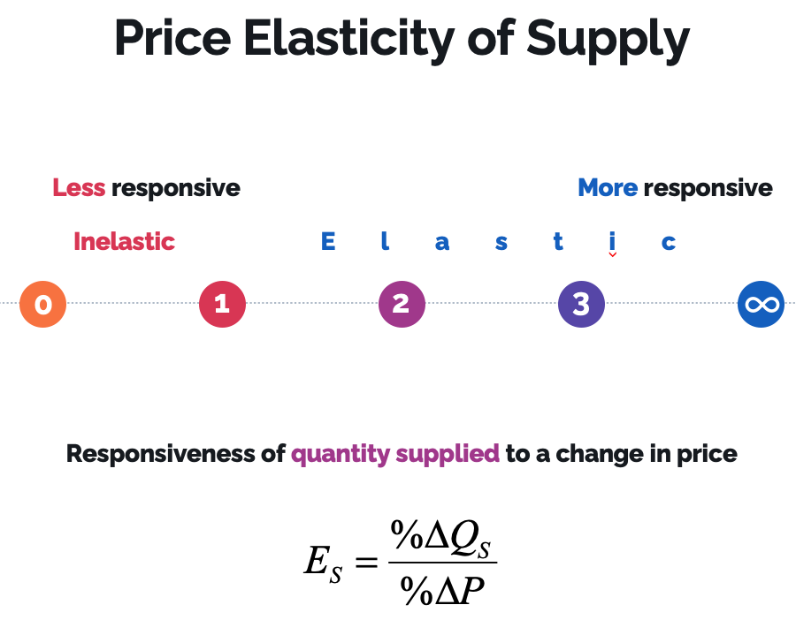

## Price Elasticity of Demand and Total Revenue

Understanding the price elasticity of demand for the product you sell is important when running a business. Consumer responsiveness to price changes determines whether a firm would be better off raising or lowering its price for a given product. In this section, we explore the relationship between the price elasticity of demand and a firm’s total revenue.

|  |  |  |  |  |  |  |
| --- | --- | --- | --- | --- | --- | --- |
| Price (dollars) | Quantity | Total Revenue $$P×Q$$ | Percentage change in price | Percentage change in quantity demanded | Elasticity coefficient (midpoint formula) | Interpretation |
| 5 | 0 | 0 | -22 | 200 | -9.1 | Highly elastic |
| 4 | 1 | 4 | -29 | 67 | -2.3 | Relatively elastic |
| 3 | 2 | 6 | -40 | 40 | -1.0 | Unitary |
| 2 | 3 | 6 | -67 | 29 | -0.4 | Relatively inelastic |
| 1 | 4 | 4 | -200 | 22 | -0.1 | Highly inelastic |
| 0 | 5 | 0 |  |  |  |  |

But first we need to understand the concept of total revenue: ***Total revenue*** is the amount that a firm receives from the sale of goods and services. Total revenue for a particular good is calculated by multiplying the price of the good by the quantity of the good that is sold. Table 4.3 reproduces the table from Figure 4.3 (table + graph)(with numbers based on the midpoint formula) and adds a column for the total revenue. We find the total revenue by multiplying the price by the quantity purchased.

After calculating total revenue at each price, we can look at the column of elasticity coefficients to determine the relationship. When we link revenues with the price of elasticity of demand, a trade-off emerges. [this trade-off occurs because total revenue and elasticity relate to the price differently; total revenue involves multiplying the price by the quantity, while elasticity involves dividing the percentage change in price.) Total revenue is zero when the price is too high ($5 or more) and when the price is too low ($0). Between these two extremes, prices from $1 to $4 generate positive total revenue.

Consider what happens when the price drops from $5 to $4…at $4, the first latte is purchased; the total revenue is $\$4×1=\$4$. This is also the range at which the price elasticity of demand is highly elastic, as result, lowering the price increases revenues; revenue continues to increase when the price drops from $4 to $3. Now two lattes are sold, so the total revenue rises to $\$3×2=\$6$, at the same time, demand remains elastic; we thus conclude that when demand is elastic, lowering the price will increase total revenue. This relationship is shown in panel (a) of Figure 4.4; by lowering the price from $4 to $3, the business has generated $2 more in revenue, but to generate extra revenue, the business has lowered the price from $4 to $3 and therefore has given up $1 for each unit it sells. This lost revenue is represented by the red area under the A diagram of a price
demand curve in panel (a).

When the price drops from $3 to $2, the total revenue stays at $6; this result occurs because demand is unitary as shown in the panel (b). This special condition exists when the percentage price change is exactly offset by an equal percentage change in the quantity demanded. In this situation, revenue remains constant. At $2, three lattes are purchased, so the total revenue is $\$2×3$, which is the same as it was when the price was $3; as a result, we can see that total revenue has reached a maximum. Between $3 and $2, the price elasticity of demand is unitary, this finding does not necessarily mean that the firm will operate at the unitary point. Maximizing profit, not revenue, is the ultimate goal of a business, and we have not yet accounted for costs in our calculations of profits.

Once we reach a price below unitary demand, we move into the realm of inelastic demand, shown in panel (c). When the price falls to $1, total revenue declines to $4; this results occurs because the price elasticity of demand is now relatively inelastic, or price insensitive. Even though the price is declining by $1, price is increasingly unimportant; as you can see by the light green square, lowering the price to $1 does not spur a large increase in consumption.

As we see in panel (c), at a price of $2, three units are sold and total revenue is $\$2×3=6$; when the price falls to $1, four units are sold, so the total revenue is now $\$4×1=\$4$. By lowering the price from $2 to $1, the business has lost $2 in extra revenue from the lower price; lowering the price from $2 to $1 causes a loss of $3 in existing sales revenue (the red boxes). At the same time, it generates only $1 in new sales (light green box), so the net change is a loss of $2.A graph of a loss

In this analysis, we see that once the demand curve enters the inelastic area, lowering the price decreases total revenue. This outcome is unambiguously bad for a business; the lower price brings in less revenue and requires business to produce more goods, because making goods is costly, it does not make sense to lower prices into the region where revenues decline. We can make sure that no business will intentionally operate in the inelastic region of the demand curve because it will earn less profit.

How do changes in Income and the Prices of other goods affect elasticity?

We have seen how consumer demand responds to changes in the price of a single good. In this section, we examine how responsive demand is to changes in income and to price changes in other goods.

# Income elasticity

Changes in personal income can have a large effect on consumer spending, after all, the money in your pocket influences not only how much you buy, but also the types of purchases you make. A consumer who is low on money may opt to buy a cheap generic product, while someone with a little extra cash can afford to upgrade. For instance, the grocery store aisle reflects different shoppers’ budget; store brands and name products compete for shelf space. Lower-income shoppers can choose the store brand to save money, while more affluent shoppers can choose their favorite brand-name product without worrying about the purchase price. ***The income elasticity of demand (EI)*** measures how a change in income affects spending. It is calculated by dividing the percentage change in the quantity demanded by the percentage change in persona income:

$$E_{I}=\frac{percentage change in the quantity demanded}{percentage change in income}$$

Unlike the price elasticity of demand, which is negative, the income elasticity can be positive or negative. When a higher level of income enables the consumer to purchase more, the goods that are purchased are ***normal goods***, because the demand for normal goods goes up with income, they have a positive income elasticity; a rise in income causes a rise in the quantity demanded. Whenever a good is normal, the result is a positive income elasticity of demand, and purchases of the good rise as income expands and purchases of the good fall as income falls.

Normal goods fall into two categories: ***necessities and luxuries***. Goods that people consider necessities generally have income elasticities between 0 and 1; although purchases of necessities will increase as income rises, they do not rise as fast as the increase in income does. Therefore, as income increases, spending on necessities will expand at a slower rate than the increase in income. Rising income enables consumers to enjoy significantly more luxuries, producing an income elasticity of demand greater than 1 for luxuries.

In chapter 3, we saw that ***inferior goods*** are those that people will choose not to purchase when their income goes up. Inferior goods have a negative income elasticity, because as income expands, the demand for these goods declines.

***Inferior good: $E_{i}<0$***

***Normal good (necessity): $0<E_{i}<1$***

***Normal good (luxury): $E_{i}>1$***

# Cross-Price Elasticity

Now we will look at how a price change in one good can affect the demand for a related good. ***The cross-price elasticity of demand*** ***(EC)*** measures the percentage change in the quantity demanded of one good to the percentage change in the price of a related good:

$$E_{C}=\frac{percentage change in the quantity demanded of one good}{percentage change in the price of a related good}$$

Consider how two goods are related; if the goods are substitutes, a price rise in one good will cause the quantity demanded of that good to decline. At the same time, because consumers can purchase the substitute good for the same price as before, the demand for the substitute good will increase.

The opposite is true if the goods are complements; in that case, a price increase in one good makes the joint consumption of both goods more expensive. Therefore, the consumption of both goods will decline.

What if there is no relationship between the two goods? The cross-price elasticity is neither positive nor negative; its zero. ***The table below lists cross-price elasticity values according to the type of good.***

|  |  |  |  |
| --- | --- | --- | --- |
| Income Elasticity | | | |
| Type of good | Subcategory | $E_{I}$ coefficient | Example |
| Inferior |  | $$E_{I}<0$$ | Macaroni and cheese |
| Normal | Necessity | $$0<E_{I}<1$$ | Milk |
| Normal | Luxury | $$E_{I}>1$$ | Diamond ring |

|  |  |  |
| --- | --- | --- |
| Cross-Price Elasticity | | |
| Type of good | $E_{C}$ coefficient | Example |
| Substitute | $$E_{C}>0$$ | Pizza Hut and Dominos |
| No relationship | $$E_{C}=0$$ | A basketball and bedroom slippers |
| Complements | $$E_{C}<0$$ | Turkey and gravy |

What is the Price Elasticity of Supply?

Like consumers, sellers are sensitive to price changes. However, the determinants of the price elasticity of supply are substantially different from the determinants of the price elasticity of demand. ***The price elasticity of supply*** is a measure of the responsiveness of the quantity supplied to a change in price.

In this section, we examine how much sellers respond to price changes. For instance, if the market price of gasoline increases, how will oil companies respond? The answer depends on the elasticity of supply. Oil must be refined into gasoline. If it is difficult for oil companies to increase their output of gasoline supplied will not increase much even if the price increases a lot. In this case, we say that supply is inelastic, or unresponsive. However, if the price increase is small and suppliers respond by offering significantly more gasoline for sale, then supply is elastic. We would expect to observe this outcome if it is easy to refine oil into gasoline.

When supply is not able to respond to a change in price, we say it is inelastic; when the supplier’s ability to make quick adjustments is limited, the elasticity of supply is less than 1; Recall the law of supply, which states that there is a direct relationship between price of a good and the quantity that a firm supplies. As a result, the percentage change in the quantity supplied and the percentage change in price move in the same direction. The $E_{S}$ coefficient reflects this direct relationship with a positive sign.

## Determinants of the Price Elasticity of Supply

When we examined the determinants of the price elasticity of demand, we saw that consumers have to consider the number of substitutes, how expensive the item is compared to their overall budget, whether the good is a necessity or a luxury, and the amount of time they have to make a decision. Time and adjustment process are also key elements in determining the price elasticity of supply. However, there is a critical difference: the degree of flexibility that producers have in bringing their product to the market quickly.

|  |  |  |
| --- | --- | --- |
| A Closer Look at the Price Elasticity of Supply | | |
| Elasticity | $E_{S}$ coefficient | Example |
| Perfectly inelastic | $$E_{S}=0$$ | Oceanfront land |
| Relatively inelastic | $$0<E_{S}<1$$ | Cell phone tower |
| Relatively elastic | $$E_{S}>1$$ | Hot dog vendor |

## The Flexibility of Producers

When a producer can quickly ramp up output, supply tends to be elastic. One way to maintain flexibility is to have spare production capacity – extra capacity enables producers to quickly meet changing price conditions, so supply is more responsive, or elastic – the ability to store the good is another way to stay flexible; producers who have stockpiles of their producers can respond more quickly to changes in market conditions. However, many businesses cannot adapt to changing market conditions quickly.

## Time and the Adjustment Process

In the immediate run, businesses are stuck with what they have on hand. As we move from immediate run to short run and a price change persists through time, supply – just like demand – becomes more elastic.

Figure 4.5 shows how the two determinants of supply elasticity are mapped onto the supply curve is vertical ($S_{1}$). A vertical curve tells us that there is no responsiveness when the price changes. As producers gain additional time to make adjustments, the supply curve rotates from $S_{1}$ (the immediate run) to $S_{2}$ (the short run) to $S_{3}$ (the long run). Like the demand curve, the supply curve rotates clockwise; in contrast, as we saw in Figure 4.2 (refer to the textbook), the demand curve rotates counterclockwise. With both supply and demand, the most important thing to remember is that more time allows for greater adjustment, so the long run is always more elastic.

### Calculating the price elasticity of supply

We can use a simple formula to calculate the price elasticity of supply; doing so is useful when a business owner must decide how much to produce at various prices. The elasticity of supply measures how quickly the producer is able to change production in response to changes in price. When supply is elastic, producers are able to quickly adjust production; if supply is inelastic, production tends to remain roughly constant, despite large swings in price.

Here is the formula for the price elasticity of supply ($E_{S}$):

$$E_{S}=\frac{percentage change in the quantity supplied}{percentage change in the price}$$

How do the price elasticities of demand and supply relate to each other?

The interplay between the price elasticity of supply and the price elasticity of demand allows us to explain more fully how the economy operates. With an understanding of elasticity at our disposal, we can conduct a much richer and deeper analysis of the world around us.

The interplay between the price elasticity of demand and the price elasticity of supply determines the magnitude of the resulting price change. We cannot observe demand in isolation without also considering how supply responds. Similarly, we cannot simply think about the short-run consequences of demand and supply shifts; we also must consider how prices and quantity will vary in the long run. Armed with this knowledge, you can begin to see the power of the supply and demand model to explain the world around us.

Conclusion

Do sellers charge the highest price possible? We can now address this misconception definitively: no. Sellers like higher prices in the same way consumers like lower prices, but that does not mean that sellers will charge the highest price possible. At very high prices, consumer demand is quite elastic. Therefore, a seller who charges too high a price will not sell much. As a result, firms learn that they must lower their price to attract more customers and maximize their total revenue.

The ability to determine whether demand and supply are elastic or inelastic enables economists to calculate the effects of personal, business, and policy decisions. When you combine the concept of elasticity with the supply and demand model from Chapter 3 (again refer to the textbook), you get a very powerful tool. In the subsequent chapters, we use elasticity to refine our models of economic behavior and make our results more realistic.